Part 1 - A/B Testing

The product team has asked for help coming up with an A/B test to increase reader engagement on our site. Please go to [businessinsider.com](http://www.businessinsider.com) and browse through the site prior to answering the below questions.

1. What do you think is something we can A/B test on our site that would help us achieve the goal of increasing user engagement?
   * 1. *In this instance, engagement should be defined as a user taking action on the website in the form of:* 
        1. *clicks (to articles or images), social sharing, subscription sign-up, email newsletter sign-up, video views, time on page, or scrolling*
     2. *For this test we will examine subscription signups. I chose this metric because the newsletter is one of the most effective ways to communicate with customers directly.* 
        1. *Newsletters are also a highly attractive way for advertisers to reach a subscription base.*
2. Describe how you would set up this A/B test so it is effective. Include an explanation of your thinking.
   1. *For an A/B test to be effective, we must look at the difference between 2 versions of page we are testing. In order to be accurate, we must have only 1 difference between the 2 versions, that way we can be sure that the difference on one page is the only thing that could have increased or decreased engagement.*
   2. *For example:*
      1. *We have 1 version of the website that has an email signup pop-up (something that would appear in the window that the user must opt out of looking at), and 1 version of the website that has a newsletter sign-up stationary in the corner.*
      2. *We would then measure the difference between sign up rates between the two versions. Whichever has the higher rate is more successful and we should implement that version on the website.*
3. Which success metrics would you choose for this A/B test and why?
   1. *We will measure the difference between signups on each page.*
   2. *For a successful A/B test, we must ensure that both groups (testing and control) have enough of a sample size to be statistically significant.*
   3. *The test group will have the testing treatment (the subscription pop-up), and the control group will have the stationary subscription sign up.*
   4. *The primary metric for success will be the in sign-up rates.* 
      1. *We want to make sure we look at the signup rates to be able to compare “apples to apples”.*
      2. *Whichever treatment has the higher sign up rate will be the successful treatment that we will give to the final website.*
      3. *Finally, we want to ensure statistical significance ( to ensure that the difference between the 2 groups is due to the treatment, rather than randomness). This is found using a simple Z-test, calculated subtracting the mean of the distribution from the value and divided by the standard deviation. (*[*source*](https://mixpanel.com/topics/statistical-significance/#:~:text=Statistical%20significance%20is%20the%20likelihood,a%20certain%20statistic%20is%20reliable.)*)*
4. How would you determine whether the test was a success?
   1. *Success is determined by a statistically significant difference between both treatment groups. Whichever group has the higher subscription rate will be considered successful.*

Part 2 - Two Feature Problem

The product team has created two different features that drive readers to the Business and Insider homepages and is considering removing one of these features to clean up the article pages.

1. Use the data provided for each site and details about the features below to perform an analysis. Write up your findings and a recommendation in a document. Feel free to include any charts you think are necessary to support your findings and recommendation.
   1. Please see “Product Analyst Write Up” document also attached
2. Outside of quantitative analysis, are there any other qualitative aspects to consider for this decision?
   1. It would be helpful to have the breakdown of each click. For example, we could break down the path of each click (homepage visit via “*Homepage”*  button or  *“recirculation bullet”.* This would tell us more information about the behavior of each feature, and could possibly lead to a machine learning algorithm that could predict user behavior, further enabling us to narrow down the most helpful features.
   2. It would also be helpful to have the path that led each click. For example:
      1. We could explore the relationship between users who come from social shares vs. users who come from SEO terms – which tactic drives homepage visitors? Which segment of users is more active on the website (reading multiple articles)?
3. Do you think you are missing any data to fully make a decision? Please explain why or why not.

|  |  |  |
| --- | --- | --- |
| **Date** | **Circulation Bullet 🡪Homepage Visits** | **Homepage Button 🡪 Homepage**  **Visits** |
| 05/01 | 123,987 | 56,543 |
| 05/02 | 45,361 | 89,766 |
| 05/03 | 76,789 | 76,567 |
| 05/04 | 88,980 | 176,980 |

* 1. I think we have a solid start with the information we have, but I would prefer to have a more granular breakdown of the data. I am curious to understand the specific behavior of each click. If I were to format the data I would start by creating something similar to the below table:
  2. However, if this is the only available information to us we can still come up with a data-driven solution, so I feel comfortable giving a recommendation.

1. Write up your findings and recommendation in the form of an email to the product manager.
   1. Hi Product Manager X!

After exploring the data from April 2020-January 2021, we see that there is a stronger relationship between the “back to homepage” button clicks and the homepage visits. I would recommend removing the “recirculation bullet” homepage link if we are trying to improve the look and feel of the articles pages on both “Business Insider” and “Insider”.

I would like to recommend adding a tag to the web analytics platform that tracks the users and their behavior, so we know exactly where the users come from to get to the homepage.

Best,

Meryl Duff

Feature 1: Recirculation Bullet

* The last bullet in a list of summary bullets at the beginning of every article.
* The feature is visible on both desktop and mobile devices.
* The bullet is also visible on all platforms outside of the direct site, such as Facebook Instant Articles, AMP, and a variety of distribution partners, such as Yahoo and MSN.

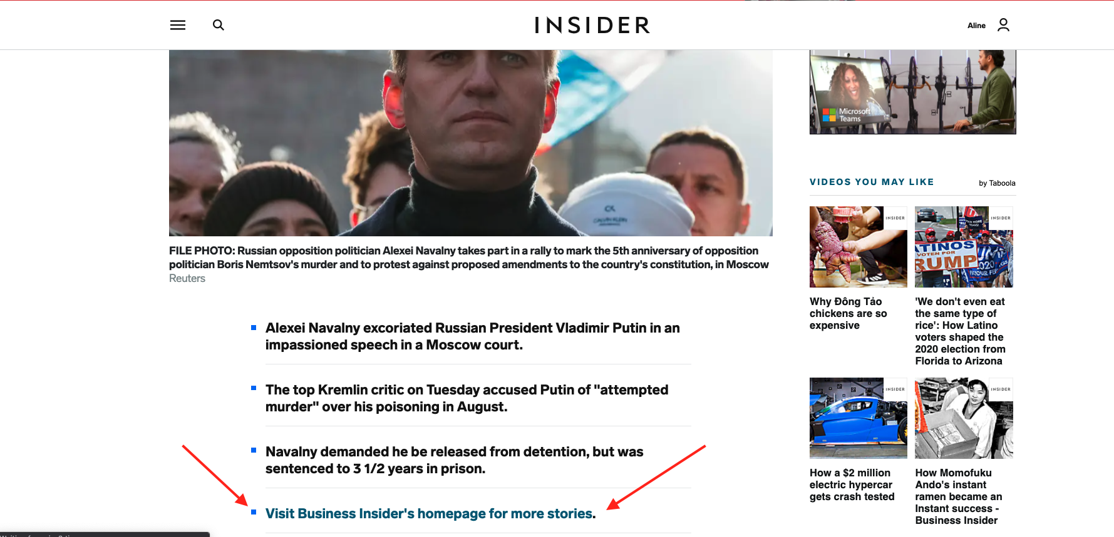

Feature 2: “Back to homepage” button

* Located on every post page in the top left corner.
* The button is only visible on mobile devices.
* The button is only visible on the direct sites and AMP. The button is not visible on platforms such as Facebook Instant Articles and our distribution partners, such as Yahoo and MSN.

